CS120 Practice Paper

Section 1 – Short-answer Questions

1. State if the following variables are valid. Provide a reason if it is not.
2. char c;
3. short _s;
4. int 1i;
5. float f_;
6. double d$;
7. long double l_d;
8. unsigned int u-int;
9. List 5 non-type keywords.
10. How many times would the while loop and the do-while loop runs at least?
11. Which line(s) in the following code is/are invalid?

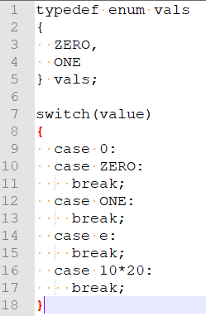

1. State if the following are lvalues or rvalues.

int i, j;

int * pi;

* 1. i
  2. pi
  3. ++i
  4. j++
  5. i+j
  6. *pi

1. Bracket the following expressions.
   1. a * b -- + c * -- b
   2. x + ++y * x - a + b
   3. ---x * y + a -- b * c++
2. What is the output for the following lines?
   1. printf(“|10, %c|”, ‘3’);
   2. printf(“|%d%d, 10, 0);
   3. printf(“|20, %f|”, 3, 1.0f);
   4. printf(“|%3d|”, 10);
   5. printf(“|%-3d|”, 10);
   6. printf(“|%2f|”, 100.0f);
3. what are the values of the variables after the following lines?
   1. scanf(“%d”, &x); input: 10
   2. scanf(“%d, %d”, &x, &y); input: 3, 3
   3. scanf(“%f %c %d, &x, &y, &z); input: 10 51 1
4. What is the output of the following program?

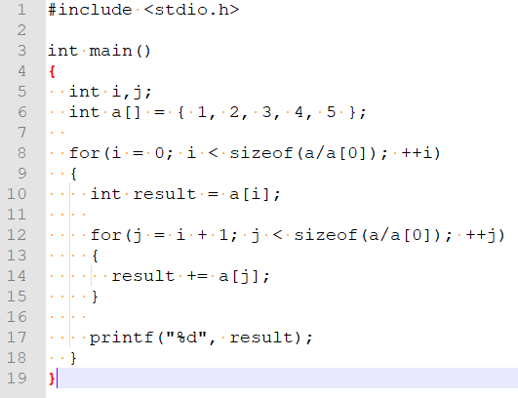

1. What is the output of the following program?

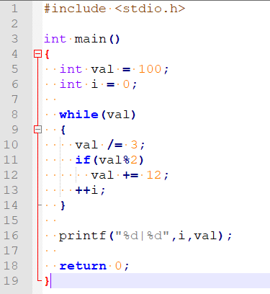

1. What is the memory layout of the following struct? Calculate the size of the struct. Assume that the start of struct S is at address 1000.

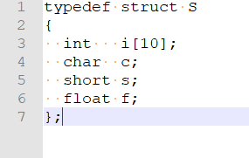

1. What is the memory layout of the following struct? Calculate the size of the struct. Assume that the start of struct S is at address 1000.

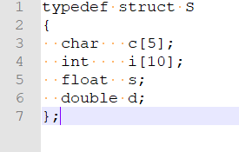

1. State if the following lines of codes are valid. Put R if there is a runtime error.

int i,j,k;

int * pj = &j;

int * pk = &k;

const int ci = 5;

* 1. ci = 10
  2. ci = i;
  3. i = ci;
  4. pj = k;
  5. *pj = *pk;
  6. pj = pk;

1. What is the address for the following lines?

double a[] = { 100.0, 200.0, 300.0, 400.0, 500.0 };

Assume that a starts at 1000.

* 1. &a[0]
  2. *(a+2)
  3. *(a+8)
  4. &++a
  5. *(a+10-5)
  6. -5+a
  7. -5+a--

Section 2 – Programming Questions

1. Write a program that reads in any file, flip the contents backwards and write it back to the file. Only pointers are allowed.
2. Write the definition of the strlen function.
3. Provide a function that takes in a pointer to an array and return the highest count of the same element.
4. Imagine that we are trying to create a local multiplayer co-op game consisting of 4 players. Using the structs provided bellow, complete the following functions.

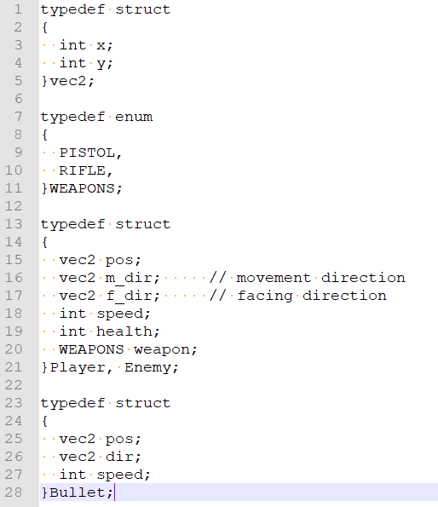

* 1. Provide a function that spawns a player or enemy at a random position.
  2. Provide a function that updates the player/enemy/bullet’s new position